Personally I feel playing a support engineer role at-least for few years makes your IT life complete and makes you better programmer, domain expert, enhances your analytical skills, improve your communication skills and lets you think in 360 degrees for every problem that invites you in this role and well, helps you in personally too. Let’s discuss few of them and prior to it, let me tell you some frequent questions heard from my friends, colleagues & from other sources.

**1) Isn't support role monotonous?**

No, on the contrary its very interesting if you have a challenging spirit and an engineering mindset. You would never know what kind of issue is coming your way after the deployments. Everyday it’s a new day, you have to be prepared with warrior spirit to encounter the challenging problems. If you feel the work is monotonous, repetitive then we have a dozen of frameworks to adopt & automate them and there is no reason why you should not automate it. Imagine the things when you automate the problems, workarounds and as a result, it reduces the human efforts. Isn’t have an immense pleasure in it.?

**2) I am a developer, Do you think support role suits me?**

Yes. Try this, work on a development project , then join a support project for a year or more and then join development project. You can see the huge difference in your analytical thinking , risk vs reward evaluation , quick decision making, debugging skills, communication aspect, self-confidence etc. I can attest this statement with many people whom I have worked with while I was in support. I always tell them that the support project has made them better developers than they were before, in-fact I myself have seen the great difference in new ways of thinking and changing the things.

**3) Will I grow up in the ladder being in support role?**

Support project often gives you a very high visibility since you are very near to the "money making machine". When stakes are high the risk/reward associated it with is also very high and hence the visibility is also high. If the job is done right, then you are immediately recognized and will be rewarded aptly (The negation of this statement holds equally good too !! ).

**4) Am I inferior compared to developers?**

Not at all, Let me take a minute to put down the bare minimum must have skills we look while looking out for support engineers.

Developer : Technical knowledge + Analytical skills + Debugging skills.

Site reliability engineer : Technical knowledge + Analytical skills + Debugging skills + Communication skills + Decision making capability + High adaptability + Sound domain knowledge + Risk/Reward evaluation capability

For an instance, developer who works on a specific technology might not have complete understanding about tools, business operations & sometimes other programming languages but as you see a site reliability or support engineer must have understanding about frontend (react.js, angular etc..), backend (Java, Python, .Net etc..), databases (SQL’s, NOSQL’s) & importantly, infra to own & resolve any business issues, he/she can never be inferior compared to developers . A good site reliability or support engineer is always a good developer, the converse always won’t hold good.

**5) Do I get to learn something new being in a support role?**

Without a doubt , YES. Every problem is a puzzle . If you love solving puzzles, you will love solving the problems too. As I mentioned earlier, you never know what problem is coming your way and every-day is a new day with a new puzzle on hand. There are so many dynamics in a support project like technology , business requirements, architecture, cache , alerts, dashboards, reports etc, You need to constantly upgrade yourself and always be a step ahead .

**My experience so far with SRE.**

**Constant evolution** : We live in an exciting time where we have a new piece of code is released almost every week. We see change in strategy, technology very often compared to what it was couple of years ago. With all these things, the need has come to be a very adaptable person and constantly evolve yourself. When you are a hands on production engineer you get to know so many things and every day is a new learning.



Personally I have been very satisfactory about my choice of playing a SRE or support engineer. There is no week without learning something new, be it domain, technology , framework , soft skills , tools, business reason for a feature etc. and always a scope of reducing OPS% using automations and through SRE strategies & methodologies.

**Thinking Hat** : A SRE role over a period of time earns you what I call a "3D thinking hat" .

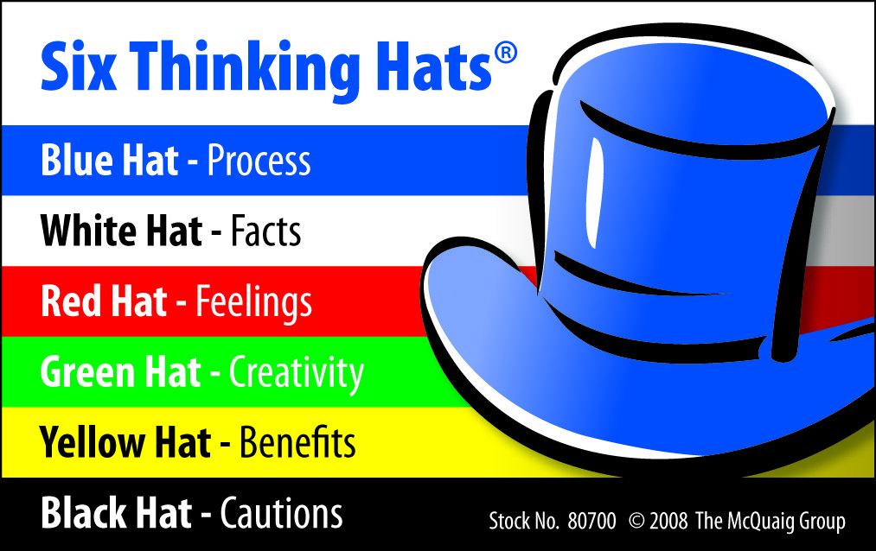

As a SRE I have to put my feet into shoes of a developer, into shoes of business owner, into shoes of infrastructure admin and think in all perspectives to assess the impact , risk and reward. I have been lately seeing development team seeking help of our SRE's , infrastructure team seeking help of our SRE's, surprisingly business team also seeking help of our SRE's to understand the best possible optimal solution. It’s a feat to achieve in itself to be respected by all the teams.

**A better engineer** : SRE has transformed me into a better engineer than I was ever. This is not only with me, As I said earlier I can attest this statement with many of my friends/colleagues who switched to development stream. I can see they have been better developers than they were before. I attribute the "3D thinking hat" for their success because now they have gotten used to solve the problem optimally, efficiently and by keeping every team's limitation/perspective in mind , not just solve the problem.

 A step closer to everything : As a SRE you are always close to reality , be it real world customer problems, performance issues, production environment, analytics data , change management process, watching the orchestration of all the layers , Clients, Client leadership. I often recall one of my lead mentioning to me in my early days "Writing code is one task, but pushing the code to production environment , ensure it runs there smooth and measure its effectiveness is another huge task to accomplish" . As a SRE I can now realize what he really meant. This is one of the reason I recommend every developer should play a SRE role once his in career lifetime.